University of Washington

iSchool Info 330

# Module 05 Assignment - SQL Programming

In this module's assignment, you will learn how create professional database designs using normalization, constraints, views, and transactional stored procedures.

## Assignment Videos

Please watch the following Videos:

|  |
| --- |
| Assignment Videos < 120 min (Links are to external sites) |
| [SQL Server Programming Part 14 - Transactions - 24](https://youtu.be/is03uRYFgqc) |
| [SQL Implicit versus Explicit Transactions - 30](https://youtu.be/pngda-1vA0A) |
| [ACID Principles - 50](https://youtu.be/8ZOTMjHiuJo) |
| [Stored Procedures-01 Stored Procedures Basics – 6](https://youtu.be/OLhqxIxphJI?list=PLfycUyp06LG_ShpiOSTkQmu69sZD2Ng13) |
| [Stored Procedures-02 Getting Info About Stored Procedures - 6](https://youtu.be/vgMgrr3QrOw) |
| [Stored Procedures-03 Stored Procedures For Transaction - 6](https://youtu.be/njnbdnEnmlc) |
| [Stored Procedures-04 Stored Procedures For Abstraction - 5](https://youtu.be/met_q37pHI0) |
| [Stored Procedures-06 Stored Procedures With Return Codes - 12](https://youtu.be/cowtDzGqiCU) |
| [Stored Procedures-07 Creating a Stored Procedure Template - 7](https://youtu.be/EEkTq2HgfIk) |
| Output [Parameter](https://www.youtube.com/watch?v=GvRv4V-AK70)s -12 |

## Assignment Examples

Read and try out some SQL statements on the Microsoft’s website. This website has short articles about many subjects. Although much more complex than the W3Schools website, this website will also become a "Go To" sites as you progress in your learning.

|  |
| --- |
| Examples < 60 min (Links are to external sites) |
| [Stored Procedures Overview](https://docs.microsoft.com/en-us/sql/relational-databases/stored-procedures/stored-procedures-database-engine) |
| [Create Stored Procedures](https://docs.microsoft.com/en-us/sql/relational-databases/stored-procedures/create-a-stored-procedure) |
| [Modify Stored Procedures](https://docs.microsoft.com/en-us/sql/relational-databases/stored-procedures/modify-a-stored-procedure) |
| [Delete Stored Procedures](https://docs.microsoft.com/en-us/sql/relational-databases/stored-procedures/delete-a-stored-procedure) |
| [Execute Stored Procedures](https://docs.microsoft.com/en-us/sql/relational-databases/stored-procedures/execute-a-stored-procedure) |

## Assignment Reading

Since the course does not have an official text you will use various websites for your studies. This is a great way to learn new subjects and practicing it will be something you will use for years to come! Please read the following web pages:

|  |
| --- |
| Reading < 120 min (Links are to external sites) |
| [tsql programming temporary tables in sql server](https://www.red-gate.com/simple-talk/sql/t-sql-programming/temporary-tables-in-sql-server) |
| [A stored procedure best practices checklist.aspx](http://sqlblog.com/blogs/aaron_bertrand/archive/2008/10/30/my-stored-procedure-best-practices-checklist.aspx%20-%2030) |
| [How to create a sql server stored procedure with parameters](https://www.mssqltips.com/sqlservertutorial/162/how-to-create-a-sql-server-stored-procedure-with-parameters) |
| [A good stored procedure template](http://jackworthen.com/2015/10/29/a-good-stored-procedure-template) |

## Assignment Document

Write a document that articulates the answers to the following questions. Use at least one well-formed paragraph per question. Using only a sentence or two is fine, but it must make sense and be well formed. (Please use MS Word or a compatible word processor)

1. Explain why constraints, views, functions and stored procedures are recommend features of a professional database design.
2. Explain how transaction statements are used in a stored procedure.

**Note:** These questions are intentionally like previous ones to allow you to improve your previous answers.

***Important:*** *Your document must look professional to get full points! Use my example template and video, in the General Files and Topics module, as a guide for what I expect a professional paper to look like. Make sure you format it like a college paper instead of the text message. Things like your name, date, class, citations, introductory and summary paragraphs are always expected! Not putting these in the document you will cost you!*

# Create a Google Blog

You will now use your Word document to create a Google Blog. The Blog does not have to look exactly like your Word document but should contain the same information.

The creation of the Blog will help you to understand how information is published on the Internet by people just like yourself. It will also give you an opportunity to start building your professional credentials now!

Here is a link to some simple instruction on how to create the Blog:

<https://www.wikihow.com/Set-Up-a-Google-Blog>

And, here is a video I created to help walk you through the process:

<https://www.youtube.com/watch?v=L8kePEXR7zk>

Other students will be reviewing it so please leave it public, but you may want to configure it not to show in Blogger's listing or search engine until you have had more practice.

**Note**: You will also be able to delete your Blog after the course is over.

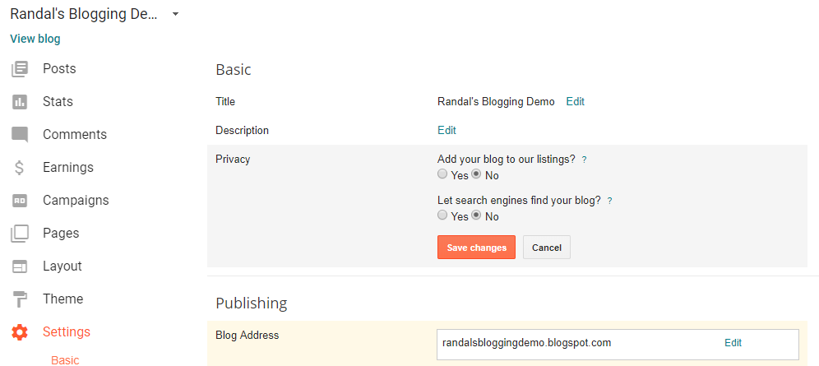

**Figure 1:** Using settings to configure privacy

# Post Your Blog

Now that you have create a Blog, you need to share it will the class. Please post this on the discussion board created for this purpose (Module 05 Blog Links.)

**Important**: Update the **Word document to** **include a link to your Blog** at the top of the page.

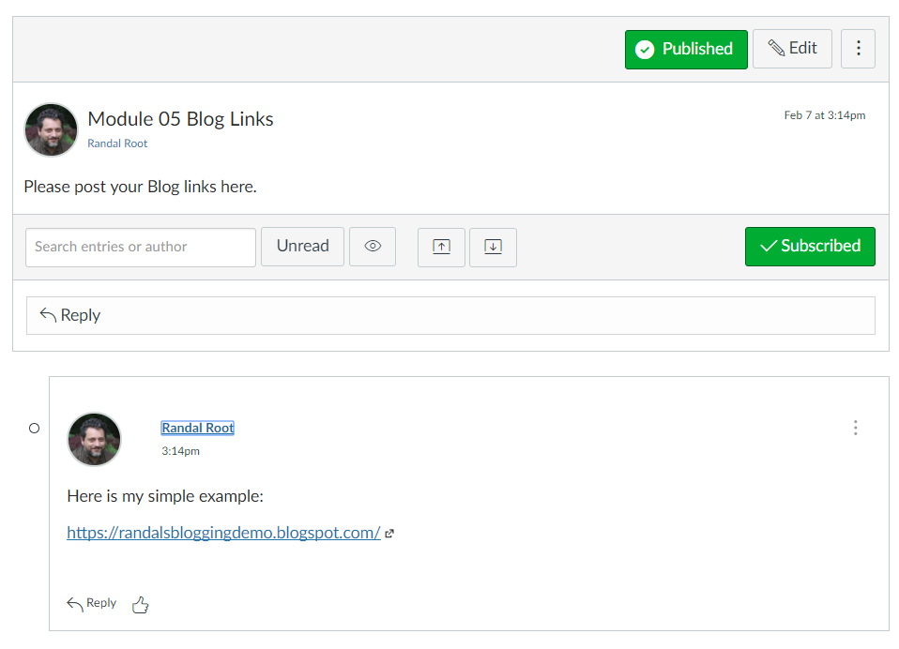

**Figure 3:** The example of posting a Blog link on the discussion board.

You Blog does not have to look great, but is should be easy to read and include pictures. Here is my simple example: <https://randalsbloggingdemo.blogspot.com/>

To post you images you need to first save them to your hard drive and then upload them to Blogger. Here is an article that will help you save your images to your drive:

<https://support.office.com/en-us/article/save-a-picture-smartart-graphic-or-slide-as-a-separate-file-3c4f9ca4-945a-4c33-af91-d10e4e3ea715>

# Review a Blog

Next you, need to review another student's work. Go to the Module 05 Blog Links on Canvas, choose another students Blog to review (one that has not already been reviewed), then go to their Blog and review it.

Your review must contain **2 things that you liked** about it and **1 thing that you feel could make is better**.

**Note:** You are **not grading** their assignment, you are only giving an informal review.

## Assignment Task

You need to also practice what you have learned in this module. To do so, you will write a SQL Script to create a new normalized database with stored procedures. **Use the provide starter file, Assignment05.sql to get you started.**

### Step 1: Create the assignment database

--*************************************************************************--

-- Title: Assignment05

-- Author: YourNameHere

-- Desc: This file demonstrates how to process data in a database

-- Change Log: When,Who,What

-- 2017-01-01,YourNameHere,Created File

--**************************************************************************--

Use Master;

go

If Exists(Select Name from SysDatabases Where Name = 'Assignment05DB_YourNameHere')

Begin

Alter Database [Assignment05DB_YourNameHere] set Single_user With Rollback Immediate;

Drop Database Assignment05DB_YourNameHere;

End

go

Create Database Assignment05DB_YourNameHere;

go

Use Assignment05DB_YourNameHere;

go

-- Create Tables (Module 01)--

Create Table Categories

([CategoryID] [int] IDENTITY(1,1) NOT NULL

,[CategoryName] [nvarchar](100) NOT NULL

);

go

Create Table Products

([ProductID] [int] IDENTITY(1,1) NOT NULL

,[ProductName] [nvarchar](100) NOT NULL

,[CategoryID] [int] NULL

,[UnitPrice] [money] NOT NULL

);

go

Create Table Inventories

([InventoryID] [int] IDENTITY(1,1) NOT NULL

,[InventoryDate] [Date] NOT NULL

,[ProductID] [int] NOT NULL

,[Count] [int] NOT NULL

);

go

-- Add Constraints (Module 02) --

Alter Table Categories

Add Constraint pkCategories

Primary Key (CategoryId);

go

Alter Table Categories

Add Constraint ukCategories

Unique (CategoryName);

go

Alter Table Products

Add Constraint pkProducts

Primary Key (ProductId);

go

Alter Table Products

Add Constraint ukProducts

Unique (ProductName);

go

Alter Table Products

Add Constraint fkProductsToCategories

Foreign Key (CategoryId) References Categories(CategoryId);

go

Alter Table Products

Add Constraint ckProductUnitPriceZeroOrHigher

Check (UnitPrice >= 0);

go

Alter Table Inventories

Add Constraint pkInventories

Primary Key (InventoryId);

go

Alter Table Inventories

Add Constraint dfInventoryDate

Default GetDate() For InventoryDate;

go

Alter Table Inventories

Add Constraint fkInventoriesToProducts

Foreign Key (ProductId) References Products(ProductId);

go

Alter Table Inventories

Add Constraint ckInventoryCountZeroOrHigher

Check ([Count] >= 0);

go

-- Show the Current data in the Categories, Products, and Inventories Tables

Select * from Categories;

go

Select * from Products;

go

Select * from Inventories;

go

### Step 2: Add data to the database

Add some starter data to your database using standard insert statements:

Category Product Price Date Count

Beverages Chai 18.00 2017-01-01 61

Beverages Chang 19.00 2017-01-01 17

Beverages Chai 18.00 2017-02-01 13

Beverages Chang 19.00 2017-02-01 12

Beverages Chai 18.00 2017-03-02 18

Beverages Chang 19.00 2017-03-02 12

### Step 3: Create transactional stored procedures for each table

Create insert, update, and delete stored procedures for each of the three tables. All stored procedures must **include** the **Begin Tran, Commit Tran, and Rollback Tran** transaction statements. All stored procedures must also include the **Try/Catch blocks** around your transaction processing code and display an **error message** if the catch block is evoked.

Create Procedure <pTrnTableName>

(<@P1 int = 0>)

/* Author: <YourNameHere>

** Desc: Processes <Desc text>

** Change Log: When,Who,What

** <2020-01-01>,<Your Name Here>,Created stored procedure.

*/

AS

Begin

Declare @RC int = 0;

Begin Try

Begin Transaction

-- Transaction Code --

Commit Transaction

Set @RC = +1

End Try

Begin Catch

If(@@Trancount > 0) Rollback Transaction

Print Error_Message()

Set @RC = -1

End Catch

Return @RC;

End

go

### Step 4: Create code to test each transactional stored procedure

Modify and use the following code to test your stored procedures.

Declare @Status int;

Exec @Status = pTrnTableName @P1 = 1;

Select [pTrnTableName Status] = @Status;

# Grading

Student work will be evaluated on a point system using the following general guidelines found on the Course Syllabus page. Make sure you read and understand this.

**NOTE:**  It is very possible to get a 3.9 or better from this course, but you have to earn it! Do not expect to get 100% of the possible points without extra effort on your part. If you want to excel in this course, you must submit **excellent**work!

# Submit your work

After you have completed your Word document and SQL Script, place both into a folder called Assignment05**FirstInitialLastName** and Zip the folder. Upload the Zipped folder to the Canvas web site.

